Applecross Senior High School
Semester 1 Examination, 2011

Question/Answer Booklet

HUMAN BIOLOGICAL SCIENCE
Stage 3

Student Name
Teacher

Time allowed for this paper
Reading time before commencing work: ten minutes
Working time for paper: three hours

Materials required/recommended for this paper

To be provided by the supervisor
This Question/Short-Answer Booklet
Multiple-choice and Extended Answer Booklet

To be provided by the candidate
Standard items: pens, pencils, eraser, correction fluid, ruler, highlighters
Special items: non-programmable calculators satisfying the conditions set by the Curriculum Council for this course

Important note to candidates
No other items may be taken into the examination room. It is your responsibility to ensure that you do not have any unauthorised notes or other items of a non-personal nature in the examination room. If you have any unauthorised material with you, hand it to the supervisor before reading any further.
Structure of this paper

Section | Number of questions available | Number of questions to be answered | Suggested working time  (minutes) | Marks available | Percentage of exam
Section One:  Multiple-choice | 20 | 20 | 30 | 20 | 20
Section Two:  Short answer | 9 | 9 | 90 | 100 | 50
Section Three:  Extended answer | 3 | 2 | 60 | 60 | 30
 |  |  |  |  | 100

Instructions to candidates

1. The rules for the conduct of Western Australian external examinations are detailed in the Year 12 Information Handbook 2011. Sitting this examination implies that you agree to abide by these rules.

2. Answer the questions according to the following instructions.

Section One: Answer all questions on the separate Multiple-choice Answer Sheet provided. For each question shade the box to indicate your answer. Use only a blue or black pen to shade the boxes. If you make a mistake, place a cross through that square, do not erase or use correction fluid, and shade your new answer. Marks will not be deducted for incorrect answers. No marks will be given if more than one answer is completed for any question.

Sections Two and Three: Write answers in this Question/Answer Booklet.

3. You must be careful to confine your responses to the specific questions asked and to follow any instructions that are specific to a particular question.

4. Spare pages are included at the end of this booklet. They can be used for planning your responses and/or as additional space if required to continue an answer.
  - Planning: If you use the spare pages for planning, indicate this clearly at the top of the page.
  - Continuing an answer: If you need to use the space to continue an answer, indicate in the original answer space where the answer is continued, i.e. give the page number. Fill in the number of the question(s) that you are continuing to answer at the top of the page.

Section One: Multiple-choice 20% (20 Marks)

This section has 20 questions. Answer all questions on the separate Multiple-choice Answer Sheet provided. For each question shade the box to indicate your answer. Use only a blue or black pen to shade the boxes. If you make a mistake, place a cross through that square, do not erase or use correction fluid, and shade your new answer. Marks will not be deducted for incorrect answers. No marks will be given if more than one answer is completed for any question.

Suggested working time for this section is 30 minutes.
________________________________________________________________________

1. Populations that are _________ are likely to undergo rapid evolution.
A) small and isolated
B) small but only partially isolated from the parent population
C) large and under diverse selective pressures
D) large and isolated from other similar species

2. Which of the following plays a role in speciation?
A) lack of phenotypic variants in a population
B) natural selection
C) geographic isolation of organisms that were once in the same population
D) Both B and C

3. In the year 2317, a group of 507 pioneers colonize Mars. The incredible distance between Mars and Earth excludes the possibility of new members joining the colony. This situation is an example of
A) genetic drift.
B) mutation.
C) the founder effect.
D) artificial selection.

4. Which of the following is least to be related to arboreal life among primates?
A) stereoscopic vision
B) reduced sense of smell
C) a clavicle
D) bipedalism

5. Which of the following is not unique to humans among living primates?
A) relative lack of body hair
B) a dish-shaped pelvis
C) opposable thumbs
D) a parabolic jaw

6. Which of the following would be considered a fossil?
A) a stone arrow head
B) an impression left by a plant on sediment that later turned to stone
C) a piece of mineralised skull
D) B and C

7. An environmental change that may have influenced the evolution of the first hominins was:
A) a trend toward greater rainfall and humidity, with an expansion of the rainforests.
B) a gradual warming of the environment
C) a drying trend, leading to the reduction of forests and the expansion of grasslands
D) the beginning of a glacial period, with falling sea levels and lessening rainfall.

8. The ease with which humans travel across the globe is likely to increase _____.
A) natural selection
B) gene flow
C) mutation
D) genetic drift

9. Imagine you are looking at a DNA fingerprint that shows a pattern of a mother's DNA and her child's DNA. Will all of the bands showing the child's DNA match those of the mother?
A) No, because a person’s DNA pattern changes with age.
B) Yes, because the DNA of mothers and children are identical.
C) Yes, because the child developed from an egg produced by the mother.
D) No, because the father contributed half of the child's DNA.

10. The bases on one strand of DNA are CTAGAAC. The complementary section on the other strand of DNA is
A) CTAGAAC
B) AGCTCCA
C) GATCTTG
D) GUTCTTG

11. Rejoining DNA fragments from two organisms is best known as
A) conjugating DNA
B) declining DNA
C) mapping genes
D) recombinant DNA technology

12. According to the fluid mosaic model of the plasma membrane, proteins are
A) spread out in a continuous layer over both membrane surfaces
B) located in the hydrophilic area of the membrane
C) oriented in a random manner throughout the membrane
D) embedded in the lipid bilayers

Use the diagram below to assist you in answering questions 13 to 14.

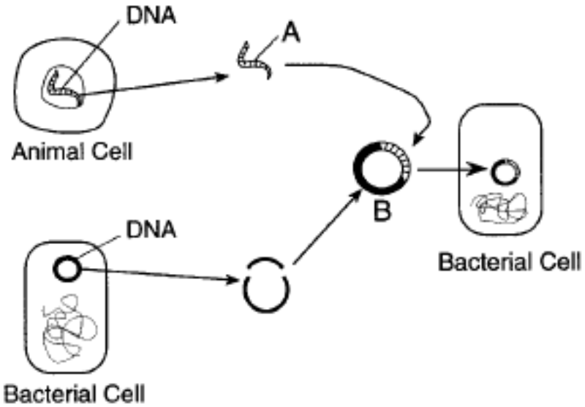

13. Structure A contains a
A) gene
B) messenger RNA molecule
C) single nucleotide, only
D) small polysaccharide

14. Structure B represents
A) a ribosome
B) recombinant DNA
C) transfer RNA
D) a female gamete

15. Which of the following statements regarding epigenetic inheritance is TRUE?
A) Epigenetic inheritance involves a change in mitochondrial DNA.
B) Epigenetic inheritance permanently affects an individual.
C) Epigenetic inheritance does not involve a change in DNA sequence.
D) Epigenetic inheritance is a temporary change in DNA.

16. Which of the following is an example of polymorphism in humans?
A) variation in emotions
B) variation in fingerprints
C) the presence or absence of a widow’s peak
D) variation in height

17. What is the key to the recognition of co-dominance?
A) The heterozygote expresses the phenotype of both homozygotes.
B) The alleles affect more than one trait.
C) The dominant alleles is not always expressed.
D) The phenotype of the heterozygote falls between the phenotypes of the homozygotes.

18. A new organism is discovered in the outback of Western Australia. Scientists have determined that the polypeptide sequence of haemoglobin from the new organism has 68 amino acid difference from humans, 62 differences from a gibbons, 24 difference from a rat, and 6 difference from a frog.
These data:
A) show that the new organism is best adapted to an aquatic environment.
B) indicate the new organism may be closely related to frogs.
C) suggest that the new organism is closely related to humans.
D) suggest that the new organisms evolved from gibbons but not rats and mice.

19. Which of these is an example of an adult stem cell?
A) A red blood cell.
B) A neuron.
C) A cell from an embryo.
D) Skin cells that produce new epithelial layers.

20. Which of the following features is NOT an important evolutionary advancement in the evolution of the arboreal primates?
A) opposable thumbs.
B) stereoscopic vision.
C) elongated snout with well-developed sense of smell.
D) the ability to see in colour.

End of Section One
Section Two: Short answer 50% (100 Marks)

This section has NINE questions. Answer all questions. Write your answers in the space provided.

Spare pages are included at the end of this booklet. They can be used for planning your responses and/or as additional space if required to continue an answer.
- Planning: If you use the spare pages for planning, indicate this clearly at the top of the page.
  - Continuing an answer: If you need to use the space to continue an answer, indicate in the original answer space where the answer is continued, i.e. give the page number. Fill in the number of the question(s) that you are continuing to answer at the top of the page.

Suggested working time for this section is 90 minutes.

Question 21 (10 marks)

a. The diagram is of three lower jaw outlines.

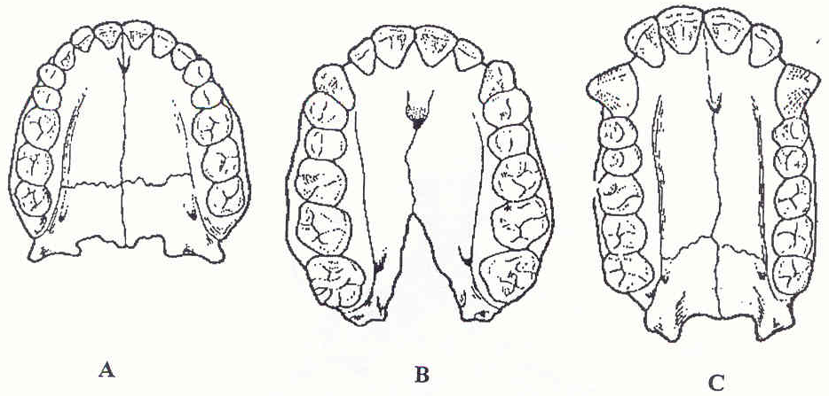

(i) Which of the three jaws is that of an ape: A, B or C?

_____________________________________________________________________________

1 mark

(ii) Give TWO reasons for your answer.

______________________________________________________________________________

______________________________________________________________________________

______________________________________________________________________________

______________________________________________________________________________

2 marks
Question 21 (cont.)

In October 2004, on the remote Indonesian island of Flores, archaeologists discovered bones from a new species of human called Homo floresiensis. These humans were much smaller than modern humans, with adults being about 1 metre in height and weighing around 25 kilograms. Bones from six or seven individuals have been discovered in sediments ranging in age from 94 000 to 13 000 years. The skeletons indicate that these humans had relatively long arms and a very small brain relative to body size, about equivalent to that of a chimpanzee. They had hard, thick eyebrow ridges and a sharply sloping forehead and no chin. Modern humans, Homo sapiens, are thought to have evolved somewhere between 55 000 and 35 000 years ago.

b. It has been suggested that Homo floresiensis evolved from a population of Homo erectus. List any two features from the fossil remains that support this view.

Feature 1 _________________________________________________________________
______________________________________________________________________________

Feature 2 _________________________________________________________________

______________________________________________________________________________

2 marks

c. Suggest and explain a method by which the ages of the bones of Homo floresiensis could be given an absolute date.

______________________________________________________________________________

______________________________________________________________________________

______________________________________________________________________________

______________________________________________________________________________

______________________________________________________________________________

______________________________________________________________________________

5 marks

Question 22 (12 marks)

The following diagram outlines events associated with the production of a polypeptide chain.
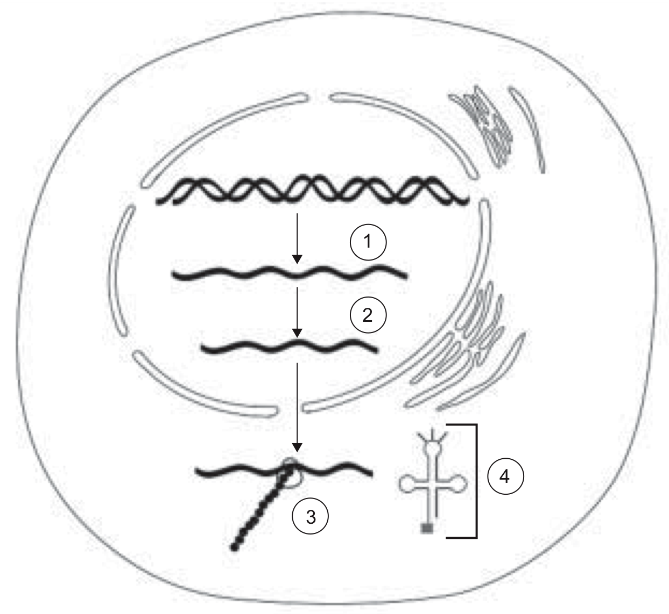
VCE 2006 Written Exam 2 page 12

- What is the name of the process at step 1?

______________________________________________________________________________

1 mark

- (i) Name the product of step 1.

______________________________________________________________________________

1 mark

(ii) Why is the strand in step 2 shorter than the strand in step 1?

______________________________________________________________________________

1 mark

c. Name the event that occurs at structure 3.

______________________________________________________________________________

1 mark
d. (i) Name the structure at 4.

______________________________________________________________________________

1 mark

(ii) Outline the function of the structure you named in the question above [Q22 d (i)]

______________________________________________________________________________

______________________________________________________________________________

______________________________________________________________________________
2 marks
Question 22 (cont.)

Below is the DNA sequence from the beginning of a gene coding for an enzyme involved in metabolism. The upper line of bases (in bold) represents the template strand.

TACTTTAAGAGCTTATCG ←template strand
ATGAAATTCTCGAATAGC

e. Write the mRNA sequence that would be transcribed from this DNA sequence.

______________________________________________________________________________

1 mark

Use the table of part of the genetic code (below) to answer part f and g.

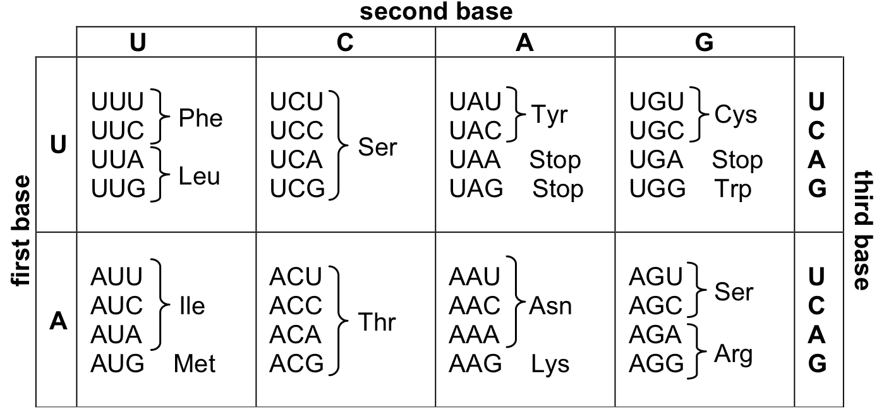

f. The 6th base on the template strand of the sequence above is substituted by C. Explain the effect this mutation will have on the amino acid sequence of the protein produced.

______________________________________________________________________________

2 marks

g. The 11th base pair of the template strand sequence is deleted. Explain the effect that this mutation will have on the amino acid sequence of the protein produced.

______________________________________________________________________________

______________________________________________________________________________

2 marks

Question 23 (13 marks)

a. Briefly explain the main ideas in Darwin’s theory of evolution.

______________________________________________________________________________

______________________________________________________________________________

______________________________________________________________________________

______________________________________________________________________________

______________________________________________________________________________

______________________________________________________________________________

______________________________________________________________________________

______________________________________________________________________________

______________________________________________________________________________

______________________________________________________________________________

______________________________________________________________________________

______________________________________________________________________________

4 marks
b. Outline the main steps involved in the process of speciation.

______________________________________________________________________________

______________________________________________________________________________

______________________________________________________________________________

_____________________________________________________________________________

______________________________________________________________________________

______________________________________________________________________________

______________________________________________________________________________

______________________________________________________________________________

______________________________________________________________________________

______________________________________________________________________________

______________________________________________________________________________

5 marks
Question 23 (cont.)

c. Outline two modern examples (within the last 300 years) where evolution can be observed and identify the selective pressures that exist.

Example 1: _____________________________________________________________________

______________________________________________________________________________

______________________________________________________________________________

______________________________________________________________________________

2 marks

Example 2: _____________________________________________________________________

______________________________________________________________________________

______________________________________________________________________________

______________________________________________________________________________

2 marks

Question 24 (8 Marks)
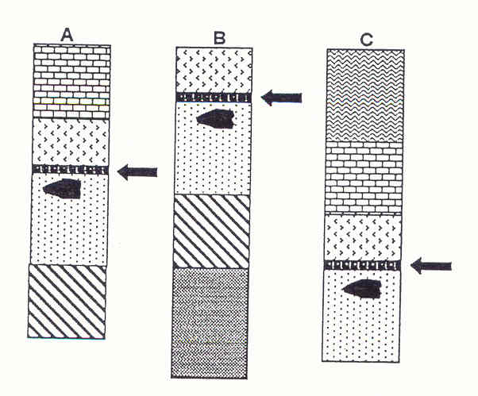

The three sets of layers from different archaeological dig sites shown above have suffered differing amount of surface erosion. A layer of volcanic ash (arrowed) has been dated to approximately
200 000 – 300 000 years ago. Crudely made stone tools are found in all sites in a discrete layer, immediately below the ash layer. Immediately above the volcanic ash is a layer with an unusual collection fossilised bones, from animals living on an ancient shoreline.

- What name is given to this method of studying rock layers in archaeology?
______________________________________________________________________________

1 mark
- Which of the dig sites A, B, or C, contains the youngest layer?
______________________________________________________________________________

1 mark
- How do you know this is the youngest?
______________________________________________________________________________

1 mark

- What name is given to a group of fossils that is found in different parts of the world and that indicates a specific period of time

______________________________________________________________________________

1 mark

QUESTION 24 (cont.)

- Carefully constructed stone tools, ash from an ancient hearth (dated at 30 000 years old), and hominin bones are found on the floor of a cave. The walls of the cave are decorated in mural art.

(i) Which of these evidences of early life is a fossil? Explain why.

______________________________________________________________________________

______________________________________________________________________________

______________________________________________________________________________

______________________________________________________________________________

______________________________________________________________________________

2 marks

(ii) Which of these evidences of early life is an artefact? Explain why.

______________________________________________________________________________

______________________________________________________________________________

______________________________________________________________________________

______________________________________________________________________________

______________________________________________________________________________

2 marks

Question 25 (17 marks)

a. Describe THREE (3) adaptations for tree life that are found in humans and in other primates, and explain how these adaptations are suited to arboreal life.

Adaptation 1

______________________________________________________________________________

______________________________________________________________________________

______________________________________________________________________________

Adaptation 2

______________________________________________________________________________

______________________________________________________________________________

______________________________________________________________________________

Adaptation 3

______________________________________________________________________________

______________________________________________________________________________

______________________________________________________________________________

6 marks

b. A team of anthropologists discovered three intact fossilised jaws, each with a complete set of teeth. The size of the teeth was calculated so that comparisons could be made between the fossilised remains. Their results are tabulated below.

Cross-sectional areas of teeth (mm²)

Tooth | Hominin 1 | Hominin 2 | Hominin 3
First incisor | 79 | 78 | 80
Second incisor | 66 | 44 | 52
Canine | 98 | 91 | 86
First premolar | 101 | 111 | 185
Second premolar | 95 | 117 | 212
First molar | 150 | 173 | 269
Second molar | 147 | 213 | 361
Third Molar | 116 | 206 | 335

(i) Why is it that teeth are the most commonly found fossilised remains of hominins?

___________________________________________________________________________

___________________________________________________________________________

2 marks
Question 25 (cont.)

(ii) Additional evidence found by the anthropologists clearly indicated that hominin 1 was a hunter-gatherer who used fire and hominin 3 did not use fire. Comment on the likely diet of hominin 3 and explain which evidence led you to your conclusion.

___________________________________________________________________________

___________________________________________________________________________

___________________________________________________________________________

___________________________________________________________________________

___________________________________________________________________________

2 marks

(iii) Based on the above evidence (including information in part (ii)) which hominin, 1 or 3, would you expect to have a larger cranial capacity? Give ONE reason to support your answer.

___________________________________________________________________________

___________________________________________________________________________

___________________________________________________________________________

___________________________________________________________________________

___________________________________________________________________________

___________________________________________________________________________

2 marks

Question 25 (cont.)

Read the extract below and answer the questions that follow.
We compared segment angles (trunk, thigh, lower-leg and foot) and joint angles (hip, knee, and ankle) for the hind limbs of bonobos walking bipedally (“bent-hip bent-knee walking,” …) and quadrupedally. Data were based on video recordings … of nine subjects in a lateral (side-on) view, walking at voluntary speed. The major differences between bipedal and quadrupedal walking are found in the trunk, thigh, and hip angles. During bipedal walking, the trunk is approximately 33– 41° more erect than during quadrupedal locomotion, although it is considerably more bent forward than in normal human locomotion. During bipedal walking, the hip has a smaller range of motion (by 12°) and is more extended (by 20 - 35°) than during quadrupedal walking. In general, angle profiles in bonobos are much more variable than in humans. Relationships of subsequent joint angles show that hip-knee coordination is similar for bipedal and quadrupedal walking, and resembles the human pattern.

Adapted from: “Segment and Joint Angles of Hind Limb During Bipedal and Quadrupedal Walking of the Bonobo (Pan paniscus)”. D’Aout, K., Aerts, P., De Clercq D., De Meester, K., and Van Elsacker, L. The American Journal Of Physical Anthropology 119:37–51 (2002)

c. What were the researchers investigating?

______________________________________________________________________________

______________________________________________________________________________

______________________________________________________________________________

______________________________________________________________________________

1 mark

d. Although researchers often look for similarities between species, this study found both similarities and differences. What were TWO of the biggest differences?

______________________________________________________________________________

______________________________________________________________________________

______________________________________________________________________________

______________________________________________________________________________

2 mark

e. With data being based on an experiment, what are TWO variables the researchers would have controlled?

______________________________________________________________________________

______________________________________________________________________________

______________________________________________________________________________

______________________________________________________________________________
2 marks
Question 26 (16 Marks)

a. Match the correct term to the description by writing the letter on the line provided.

TERM

A. Co-dominant

B. Multiple allele

C. Allele

D. Polygenic inheritance

E. Gene expression

F. Intron

G. Exon

H. Epigenetic inheritance

I. Gene pool

J. Allele frequency
DESCRIPTION

_______ Many pairs of genes influence a characteristic.

_______ Traits that have been inherited, may or may not be expressed.

_______ “Junk DNA” that does not code for traits.

_______ Both alleles for a trait are expressed.

_______ There are more than 2 different alleles for a trait.

_______ The sum of all alleles in a population.

6 marks

b. Complete the following table summarising differences between DNA and RNA.

DNA or RNA ? (circle) | DNA or RNA ? (circle)
Single-stranded
 | Base pairs: C-G, A-T
 | (Cytosine – Guanine
 | Adenine – Thymine)
Ribose sugar group

6 marks

Question 26 (cont.)

c. PCR is an important technique in which a section of DNA can be recognised and then amplified in a test tube.
(i) What does the acronym PCR stand for?

______________________________________________________________________________

1 mark

(ii) The key to successful PCR is an appropriate set of primers. What are primers and what do they do?

______________________________________________________________________________

______________________________________________________________________________

______________________________________________________________________________

______________________________________________________________________________

______________________________________________________________________________

3 marks

Question 27 (6 marks)

- What is meant by the term MUTATION?

______________________________________________________________________________

______________________________________________________________________________

1 mark
- Why are mutations an essential component of natural selection?

______________________________________________________________________________

______________________________________________________________________________

_____________________________________________________________________________

1 mark

- Apart from mutations name two other factors that are necessary before natural selection can take place.

______________________________________________________________________________

______________________________________________________________________________

______________________________________________________________________________

______________________________________________________________________________

2 marks
Question 27 (cont.)

Carefully read the information below.

In Nepal, the many Himalayan valleys have been an inhabited region for thousands of years. The valleys are steep sided and many isolated villages can be found at their peaks. These villages consist of 200 – 300 people. Despite the fact that they live in identical climatic and environmental conditions, there is a great deal of variation between the villages in the gene frequency of blood groups.

Scientists have rejected the idea that natural selection has accounted for these differences and believe random genetic drift to be the more likely reason.

- From the information provided, identify two reasons why scientists may believe that random genetic drift has caused the difference in gene frequencies.

______________________________________________________________________________

______________________________________________________________________________

______________________________________________________________________________

______________________________________________________________________________

______________________________________________________________________________

______________________________________________________________________________

2 marks
Question 28 (8 marks)

Read the passage below on genetic engineering and insert the most correct word.

Viruses that infect bacterial cells are called ___________________________. A key breakthrough that lead to recombinant DNA technology was the discovery that certain enzymes in bacteria are able to restrict the duplication of infecting viruses, by cutting up the viral DNA. Scientists discovered that this enzyme always cuts the DNA at a point where there is a specific sequence of bases. This is known as a ________________________ site and the enzyme that cuts the DNA is a called a ____________________ enzyme, because it restricts the duplication of bacteriophages. Some enzymes produce a straight cut at the sequence, while others produce a staggered cut. A straight cut is when the enzyme makes a clean break across the two strands of DNA to produce a ________________ end. In this case both strands terminate in a base pair. On the other hand, some enzymes produce a staggered cut resulting in fragments with a ______________ ________. This is a stretch of unpaired nucleotides in the DNA molecule that overhang at the break in the strands. They also have the ability to combine with sections of DNA that have a complementary ending, are very useful in recombinant DNA technology. A single-stranded overhang from one fragment can be paired with any other fragment of DNA from a different organism.
The enzyme DNA-_____________ could also be called a “DNA joining enzyme”. The process of “gluing” two ends together is called _______________.
Once a gene of interest has been isolated it can then be inserted into a vector to be cloned. The target will be circular, double-stranded units of cytoplasmic DNA called __________________. Once here the gene is duplicated and can be used in other applications.
8 marks
Question 29 (10 marks)

Genomic imprinting refers to a mechanism whereby only one of the two parental alleles is normally expressed while the other parental allele is not transcribed. The epigenetic marks associated with imprinted genes have recently been examined, and it is clear that DNA methylation, histone acetylation, and histone methylation influence the expression of particular alleles.
One of the most intensively studied imprinted genes is the gene that encodes the IGF-II receptor/mannose-6-phosphate receptor (IGF2R). The expression of this gene has been linked to suppressing tumors.

Adapted from: The Histone Code Regulating Expression of the Imprinted Mouse Igf2r Gene
Yang Y, Li T, Vu T, Ulaner A, Hu J, and Hoffman, A. Endocrinology 144(12), 2003

A new drug (“Drug X”) is being trialed to “reveal” the IGF-II gene to be transcribed, causing the gene to be fully expressed. In this experiment 2 groups of mice are being given Drug X: 10 mice with cancer and 10 without cancer. If the drug works, the IGF-II gene will be expressed in the cells and tumor size will not increase.

a. State a suitable hypothesis

______________________________________________________________________________

______________________________________________________________________________

1 mark

b. What is the independent variable in this experiment?

______________________________________________________________________________

1 mark

c. What is the dependent variable?

______________________________________________________________________________

1 mark

d. Is there a control group? Why do you think there is/isn’t?

______________________________________________________________________________

______________________________________________________________________________

2 marks

e. Why do researchers have a control group?

______________________________________________________________________________

1 mark

Question 29 (cont.)

f. What are 2 variables that should be controlled?

______________________________________________________________________________

______________________________________________________________________________

2 marks

g. What is one ethical consideration that must be made?

______________________________________________________________________________

1 mark

h. What is one thing the researcher could do to make the results more reliable?

______________________________________________________________________________

______________________________________________________________________________

______________________________________________________________________________

1 mark

End of Section Two
Section Three: Extended answer 30% (60 Marks)

This section contains three (3) questions. You must answer two (2) questions. Write your answers in the booklet provided.

Spare pages are included at the end of this booklet. They can be used for planning your responses and/or as additional space if required to continue an answer.

Planning: If you use the spare pages for planning, indicate this clearly at the top of the page.
Continuing an answer: If you need to use the space to continue an answer, indicate in the original answer space where the answer is continued, i.e. give the page number. Fill in the number of the question(s) that you are continuing to answer at the top of the page.

Responses could include clearly labelled diagrams with explanatory notes; lists of points with linking sentences; clearly labelled tables and graphs; and annotated flow diagrams with introductory notes.

Suggested working time for this section is 60 minutes.

______________________________________________________________________________

Question 30 (30 marks)

a) Compare the 3 methods (CARRIER MEDIATED TRANSPORT, DIFFUSION and VESICULAR TRANSPORT) of transporting substances into and out of the cell.
Give an example of substances that might use these methods.

20 marks

b) Discuss the relationship between the change in diet and the change in skull, jaw and ultimately brain size during hominin evolution.
10 marks

Question 31 (30 marks)

(a) Explain and discuss the adaptations possessed by Homo sapiens that allow them an upright stance and the ability to walk bipedally.
15 marks

- One possible ancestor of Homo sapiens was Homo erectus. From evidence, archaeologists and anthropologists believe that Homo erectus lived in a hunter-gatherer society and had the use of fire. What is a hunter-gatherer society? Describe, in some detail, the roles of members within this society and how the use of fire contributed to this lifestyle.

15 marks

This area has been left blank intentionally

Question 32 (30 marks)

Question 32 is comprised of THREE (3) parts: A, B and C. You must answer all sections.

Part A

Malaria is a parasitic disease widespread in the tropics and transmitted by mosquitoes. Sickle-cell anaemia is a recessive gene disorder found in a relatively high proportion of people from tropical Africa. People carrying a single copy of the gene, (Aa), are generally healthy and less susceptible to malaria than people who do not carry the gene (AA). People who are homozygous for this gene (aa) are also less susceptible to malaria, but develop a form of anaemia that is almost always fatal.

Define what is meant by natural selection. Also describe how this trait has arisen and remained prevalent in this population.
10 marks

Part B

Evolution by natural selection is a commonly accepted theory for the appearance of diverse forms of life on earth. Discuss SIX (6) lines of evidence that suggests all vertebrates may have arisen from a common ancestor.
12 marks
Part C

The diagram below shows the front and side view of an Australopithecine.

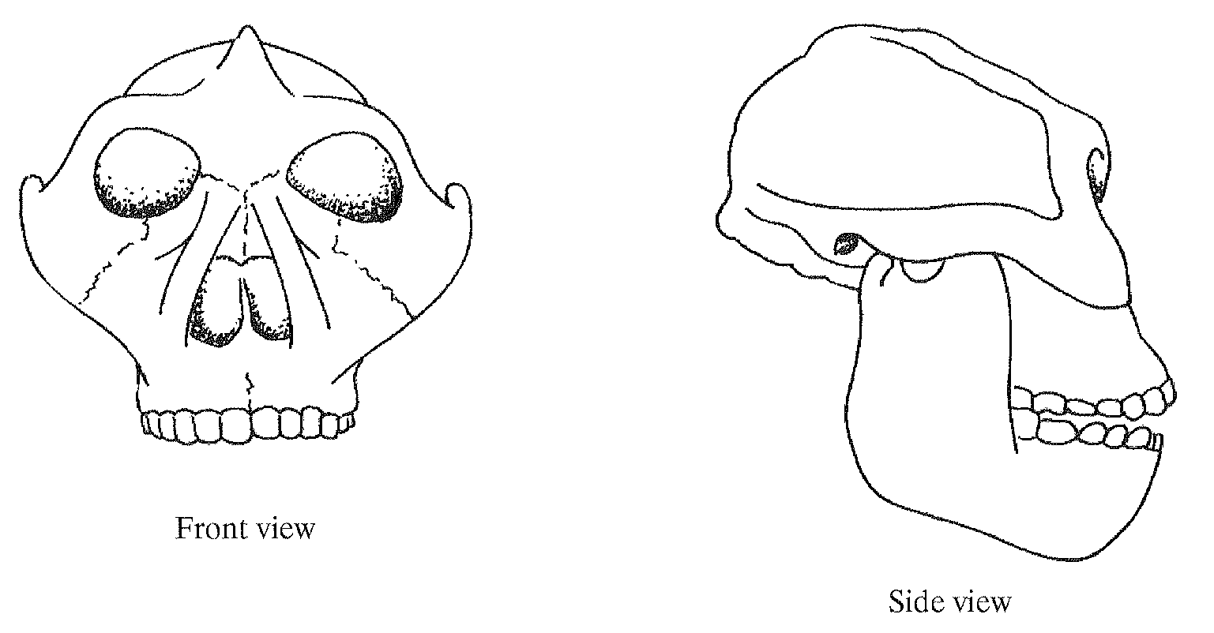
Image from: AS: AQA Human Biology, Lowrie, P. Published by Nelson Thombes 2009. P181

- What physical evidence would you be looking for on the posture, brain size and diet of this Australopithecine skull? What conclusions are likely to be drawn from this evidence?

- What method would you use to give an absolute time period of when this organism was alive?

- Describe one assumption that must be made using this method of dating.

8 marks
End of Section Three

This page has been left blank intentionally

